A Guide to Blogging
Tuesday 2 February 2016
If you are unfamiliar with blogs, they are online journals. Blogs are essentially websites where administrators (in our case your child’s class teacher) can add posts which are displayed in reverse chronological order. There are icons on the side, called widgets, where you can find past posts, recent comments, links to other blogs, our global visitors and more. We use our blog to document what is happening in our classes and to connect with parents and family members around the world.
Where can I find the blog?
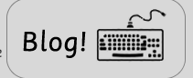
Your child’s class blog can be accessed at www.cromwellacademy.com. You must then select PUPIL ZONE and select your child’s class page. On that page you will find the BLOG button. Clicking on this will take you to your child’s class blog.

How does my child post on the blog?
Once you are on the class blog page, find the post that your child would like to comment on. Click the button that says ‘Leave a comment.’ This is usually located at the bottom of the chosen post.
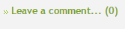 Clicking on this will take you to a page that looks like this:
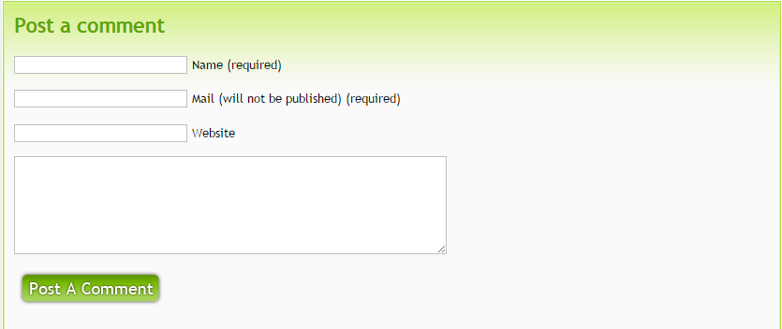
Your child can then enter their comment into this box.
The email address to enter is
blogging@cromwellacademy.com
Your child must enter their first name only in this box.

Is the blog safe?
Here at Cromwell Academy, we are committed to safeguarding. Through their class blog, your child will have the opportunity to learn about appropriate online behaviours in a supervised setting.
The following guidelines have been established to ensure the safety of our students when blogging.
• Students’ first names, photos, work, videos and school name MAY be included on the blog(s).
• Students’ surnames, address, email address, phone number, specific plans, date of birth and other personal information WILL NOT be included on the blog(s).
• All comments have to be screened and approved before they are included on the blog(s).
• Students will be encouraged to comment on other class/student blogs with teacher/parent supervision.
• Parents who leave comments are asked to use their first name only so as not to identify their child. E.g. please identify yourself in comments as “Jane – Sally’s mum” rather than “Jane Brown – Sally’s mum”.
• All comments must be polite, respectful and courteous.
• Others’ work, images, music or videos will not be used without permission and attribution.
• Parents and carers are asked to proofread comments and posts that students write on blogs at home.

Our blog is a collaborative effort. While your child’s class teacher moderates all comments and posts, please let us know if you think we have overlooked any breeches in our safety guidelines and we will correct them ASAP!

PLEASE DO NOT HESITATE TO SPEAK TO YOUR CHILD’S CLASS TEACHER SHOULD YOU HAVE ANY FURTHER QUESTIONS!

Happy Blogging

